
Assignment Front Cover Sheet

Student Name: | Bikkumalla Anish
Student ID: | 17000385
Degree Title: | MSc Global Finance
Level: | RQF LEVEL 7
Module Title: | Equity and Fixed Income Strategies and Derivatives
Module Code: | 7038MECO
Seminar Lecturer: | Binsheng Qian , Shahzeb Mohammed

Assignment Title: | Equity and Fixed Income Strategies and Derivatives Report
Word Count: | 3945

Link:  To shared files, wordpress.com Blog, etc. | [Insert link here if relevant]

By submitting this assignment, I confirm that:

- I have read and understood the University’s Academic Integrity Guidance and that in the attached submission I have worked within the expectations of the Regulations Governing Academic Integrity.
- I am aware that failure to act in accordance with Appendix 1 of the General Regulations may lead to the imposition of penalties which, for the most serious cases, may include termination of studies.
- I consent to the University copying and distributing any or all of my work in any form and using third parties (who may be based outside the UK/EU) to verify whether my work contains plagiarised material, and for quality assurance purposes.

Academic Integrity Declaration:

I, Bikkumalla Anish, am aware of the requirements of good academic practice and the potential penalties for any breaches.

I, Bikkumalla Anish, confirm that this submission is my own work and I accept all responsibility for any copyright infringement that may occur as a result of this submission.

Date of Submission: | 3/07/2026

Table of Contents
1. Introduction 3
2. Part A: Equity Investment Strategy 3
3. Part B: Fixed Income Investment Strategy 8
4. Investment Strategy 11
5. Derivatives and Risk Management 13
6. Conclusion 16
References 17

1. Introduction
This report embodies a comprehensive analysis of investment strategy in the equity, fixed income and derivatives markets that lead to a logical portfolio recommendation. Section A engages absolute and relative valuation of three publicly traded consumer retail corporations WMT, TGT, and Costco Wholesale Corporation (COST) in the United States to clarify whether or not current market prices are associated with fair value. Section B compares two corporate bonds to a five-year objective in funding long-term liabilities, using the analysis of duration and convexity of the interest rate risks (Chen & Deng, 2023). Section C combines these results in an active-versus-passive strategy recommendation of equities, bond and the overall portfolio. Section D develops an options-based build around the 2020 U.S. Presidential Election, using the Black-Scholes-Merton (BSM) model to price the position and assess the realised profitability of this position. In the analysis, current market data is used as at July 2026 and historic market data is used where appropriate and the weaknesses inherent in each type of valuation is also recognised (Chen, 2021).

2. Part A: Equity Investment Strategy
Walmart, Target, and Costco have been chosen because they are in the same U.S. consumer discretionary/discount retail industry where it is possible to make a significant relative comparison but shows a significant difference in growth, margin and capital allocation profile. They all have a high degree of capitalisation, are mature and dividend paying as well as retailing businesses, which justifies the application of the Dividend Discount Model (DDM) as the main absolute valuation tool of each of the three companies, as per the requirement of dividend payers in the assignment brief.
Absolute Valuation: Dividend discount model
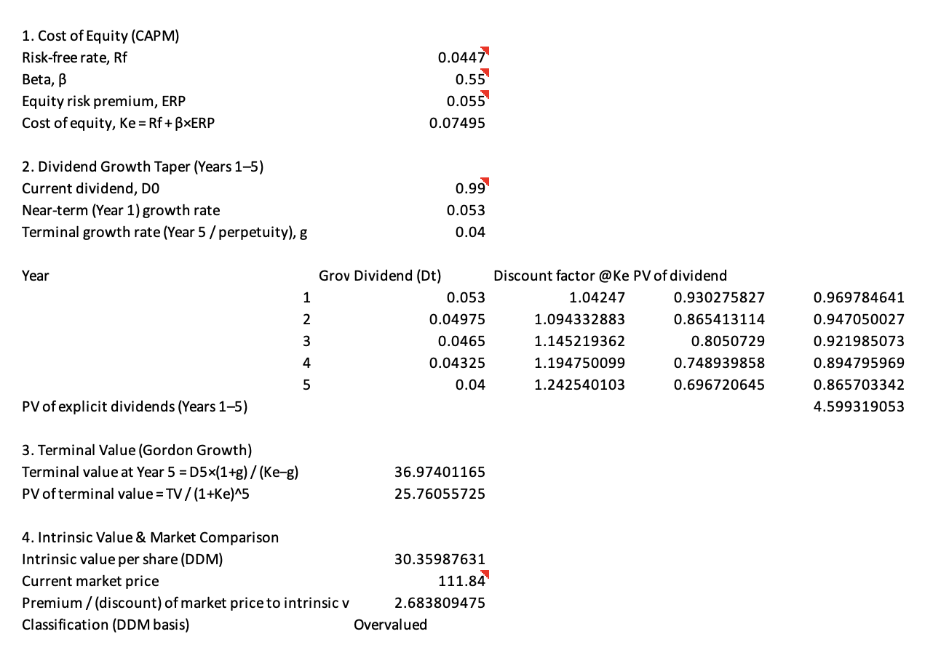
Figure 1: DDM walmart
Each company was subjected to a two step DDM. The Capital Asset Pricing Model (CAPM) was used to estimate the required return on equity (Ke) of each of the stocks: Ke = Rf + 8(ERP); the risk-free rate was 4.47% (the current yield on the 10-year Treasury, U.S. Department of the Treasury, 2026), and the equity risk premium was 5.5%. Betas represent the relative earnings and share-price swings of each company: Walmart (0.55) is defensively low-volatility, membership-renewal-related cyclicity Costco, and (1.05) is more sensitive to discretionary retail-cycle volatility due to its recent execution difficulties (Gálvez, 2023).
In both cases, the most recently announced dividend growth was used to set near-term growth in dividends which were then tapered on a five-year explicit forecast period to a sustainable terminal growth rate and a Gordon Growth terminal value was applied.
Walmart (WMT)
To keep the ongoing streak of raising dividend, Walmart announced an increase in annual dividend to $0.99 per share starting fiscal 2026, a year after it increased to 52 with running years of dividend growth. With ke= 7.50 percent ( 2 = 0.55 ), growth of 5.3 percent in the near run which decelerates to a terminal growth rate of 4.0 percent, the two-stage DDM will give an intrinsic value of about 30.36 per share (Yahoo Finance, 2025).
This means that Walmart is very overvalued based on a pure DDM value at a market price of $111.84 the model-implied value on a pure DDM should be around 73% less than the traded value (Gankhuu, 2022).
Costco (COST)
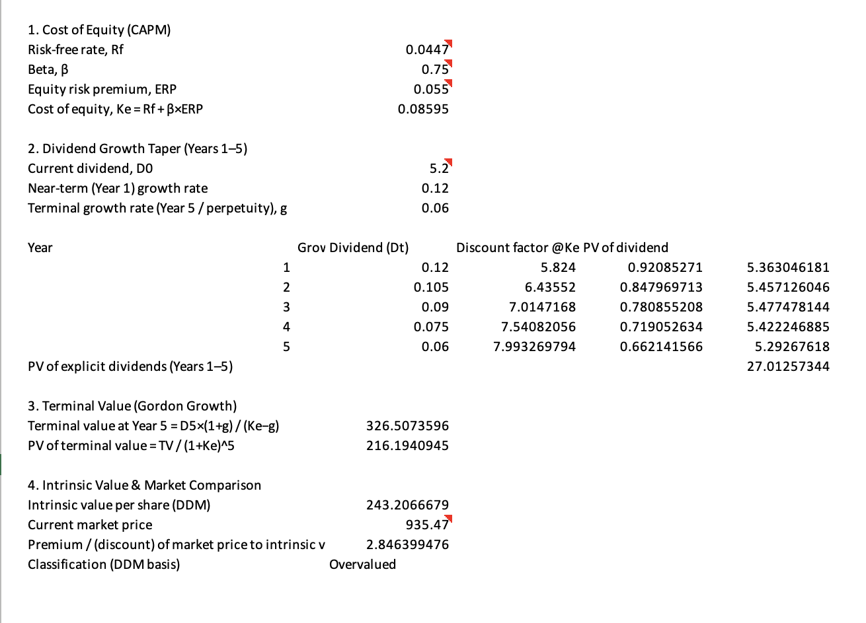
Figure 2: DDM Costco
In April 2025, the Board of Costco raised its current quarterly payments to shareholders by about 12% by raising the annualised dividend on share to 5.20 on the existing dividend rate of 1.16, bringing their dividend to 1.30 per share. The DDM, with chop growth of 12% with a taper to 6 results in an intrinsic value of some $243.21/share (assuming Ke = 8.60 percent, 0.75), over a period of three years versus a market price of $935.47 once more reflects greatly overvalued holding on pure dividend basis (Yahoo Finance, 2026).
Target (TGT)
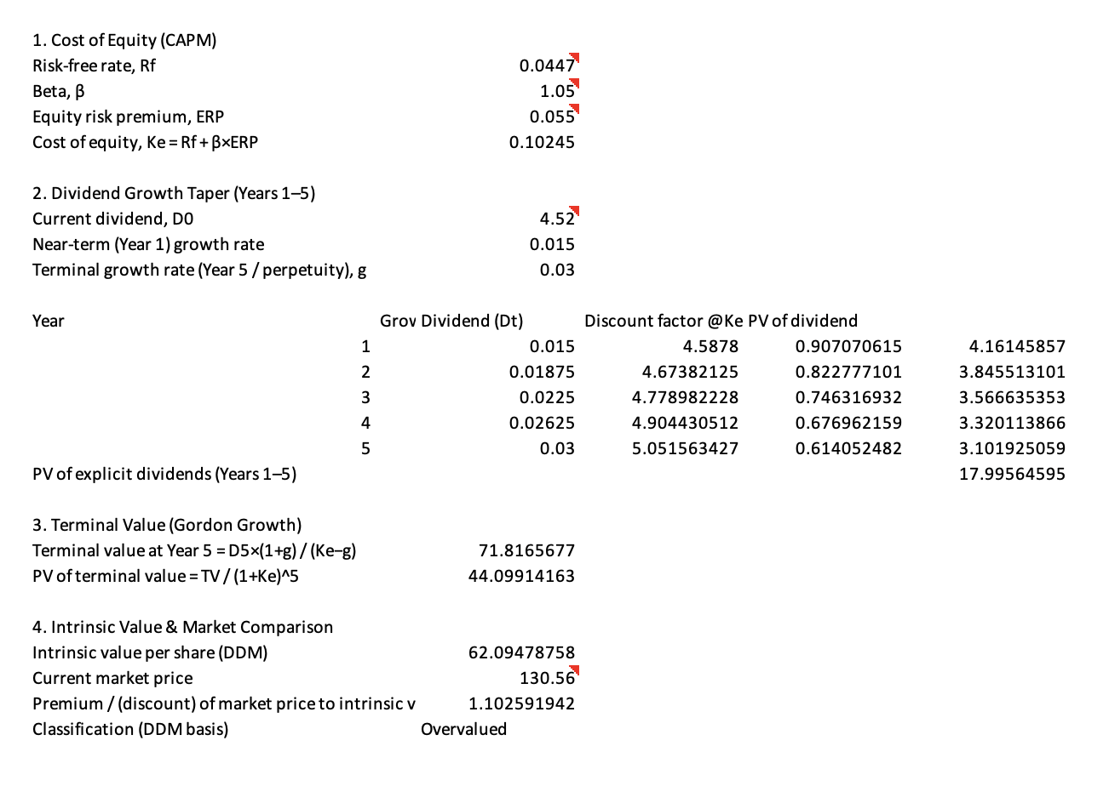
Figure 3: DDM Target
The dividend growth of Target has decreased more compared to the past, thus, indicating the underperformance in its operations (Yahoo Finance, 2024). With approximate annualised dividend of 4.52, Ke equals 10.25% (1.05) and near-term growth at 1.5 percent increasing to a terminal rate of 3.0 percent, DFM gives an intrinsic value of about 62.09 per share which is less than the market value of 130.56 per share (Li et al., 2022).
DDM Results
The three companies seem to be grossly overvalued to a pure DDM lens. It is a widely reported shortcoming of the DDM when used on large-cap growth oriented retailers whose total shareholder return is provided not by dividends, but by significant amounts of share buybacks (as well) Walmart is in the 35% range with its payout ratio, which implies that DDM is capturing a minor portion of the cash being paid out to shareholders. To this end, DDM output in this case ought to be thought of as a lower-bound, dividend-only representation of value of a point, as opposed to a full measure of intrinsic value, and triangulated with relative valuation multiples below (Yahoo Finance, 2024).
Relative Valuation
Two valuations multiples which were followed by Price-to-Earnings (P/E) and Enterprise Value-to-EBITDA (EV/EBITDA) were compared to a peer-group of five discount/warehouse retailers: Walmart, Target, Costco, Dollar General, and Dollar Tree.
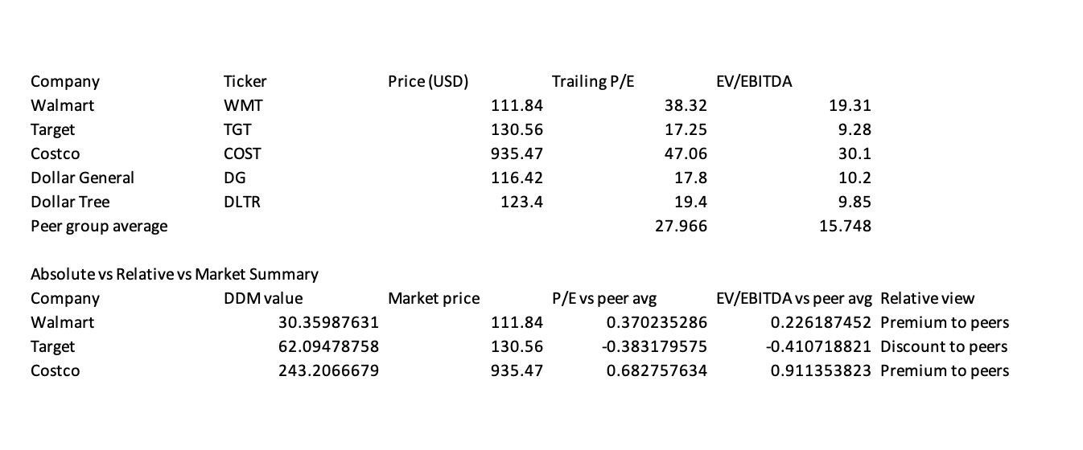
Figure 4: Relative valuation
The average P/E ratio of the peer group is about 27.9x, the average EV/EBITDA ratio is about 15.7x. Based on this, Walmart (38.3x P/E) and Costco (47.1x P/E) are heavily characteristics of their scale, options of digital/advertising growth, and low cyclicality, and are not at all characterized by higher premiums compared to the peer group. Target has a lower price relative to the group average (17.3x P/E, 9.3x EV/EBITDA) as the market is concerned with its performance in executing and generating traffic over the recent past.
Classification and Recommendations
The fact that the absolute and relative valuation of Target diverges tells us something: DDM implies that the stock is overvalued (its dividend is low comparing to value), its relative multiples imply that the stock is cheap compared to others. This reconciliation is headed towards a market that has already penalized Target on its operations weaknesses such that additional multiple compression is less likely to cause the company to continue underperforming as compared to the DDM as it itself would indicate. It is highly advisable to have a Hold till there is indications of a turnaround in similar sales (Maharani & I Made Narsa, 2023).
In the case of Walmart and Costco, both approaches directionally agree with the market price which is much higher than dividend-implied intrinsic value and above peer multiples but this is the pricing of the market in in-store execution, digital/advertising monetisation as in the case of Costco and membership economics (not taken into account by a dividend-only model). Existing holders should be held rather than the new capital of a margin of safety should be sold with a bias rather than it being an outright Sell recommendation because of the risks of shorting structurally sound compounders on valuation principles alone.
Reasons why it is mispriced and Limitations
The difference between DDM-implied and market values could be explained by a number of factors: low payout ratios in comparison with high levels of free cash flow generation (they are in particular at Walmart and Costco where buybacks and reinvestment absorb most of the cash return); they could be also explained by sector sentiment favouring resilient and high-visibility retailers in the context of a weakening labour market, and by company-specific catalysts such as ads and developing marketplaces at Walmart and membership-fee pricing power at Costco that absorb most of the cash return. The DDM is quite sensitive to the supposed growth-Ke spread; a 1-percentage-point variances in either of the two inputs has substantial impacts on the terminal value, and it is implicitly assumed that dividend policy (not buybacks) is in practice the main form of value-transfer mechanism. Relative valuation, in its turn, can embed under- or over-valuation of the sector as the peer set can only be as reliable as the comparability. The two approaches then need to be seen as complementary means of triangulation as opposed to accurate fair value estimates (Yang & Shi, 2023).

3. Part B: Fixed Income Investment Strategy
A liability of $1,000,000 is due in five years. There are 2 annual-coupon corporate bonds of 15-percent interest with a face value of 100: Bond A (5-year maturity, price of 118.95) and Bond B (10-year maturity, price of 130.72) in a Flat yield curve of 10%. The quoted prices agree exactly with a discounted cash flow value at a yield of 10% indicating internal consistency in the scenario data.
The liability funding analysis with Bond A was conducted to determine the cost of funding the liability.
Since the liability is due on the same date as Bond A matures, Bond A is the natural instrument of fund (a simple cash-flow approach matching approach) (Bank, 2024). The individual investment in Bond A will produce 5 annual coupons of $15 that is reinvested at the 10% interest rate as well as a redemption of 100 at the end of year 5. The value of each unit of the bond in year 5 will be:
FV per bond = Σ [15 × (1.10) ^(5−t)] for t = 1 to 5, plus $100 redemption = $191.58
To accumulate $1,000,000 at year 5, the number of Bond A units required is $1,000,000 ÷ $191.58 = 5,219.85 units. The original investment amount today is: at a purchase price of 118.95-/unit.
Initial investment = 5,219.85 × $118.95 ≈ $620,900.79
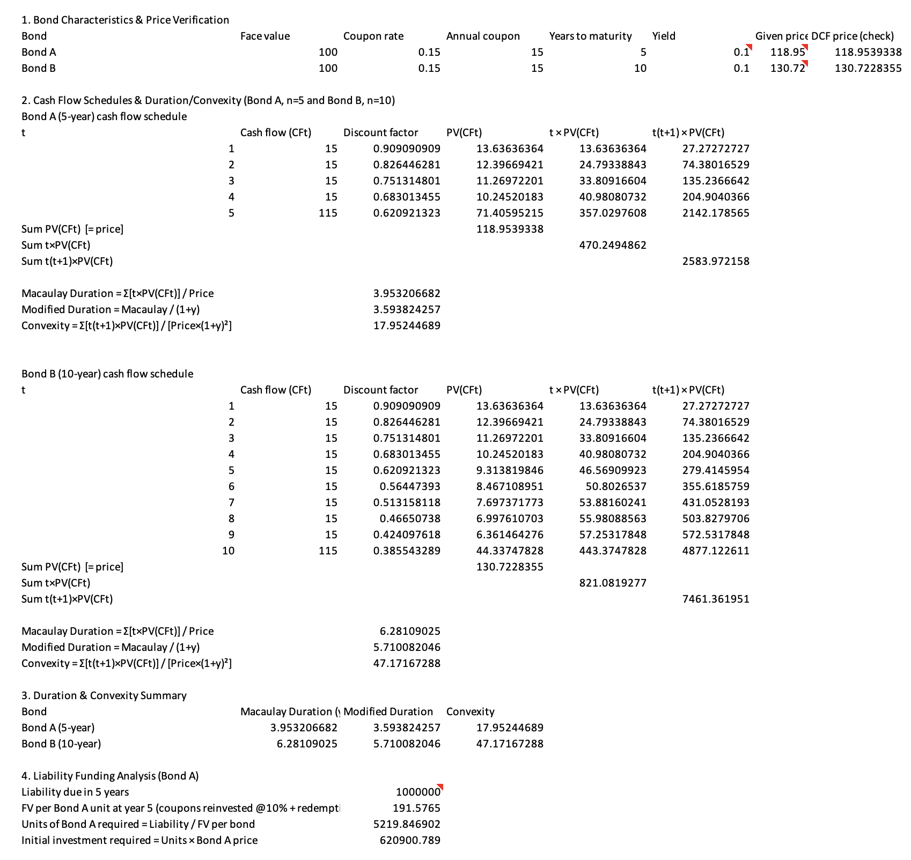
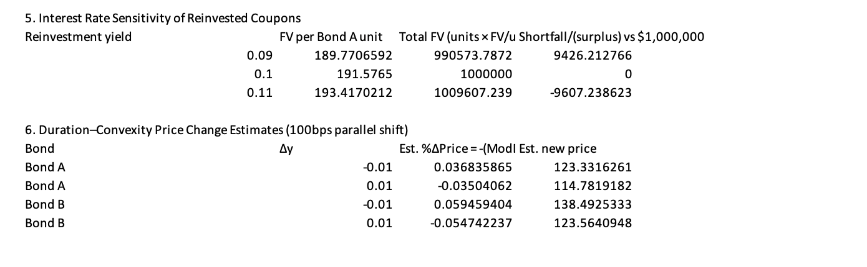
Figure 5: Bond Analysis
This proves the fact that a current investment of around 620,901 in Bond A, and the reinvestments made at are as per the current yield of 10 per cent. is enough to meet the 1,000,000 liability of five years a multiple, which is 1.10 multiplied by 1.10 and therefore 1.611 of the current investment.
Interest rate sensitivity Analysis
Since the fixed $15 annual coupons already reinvest at the rate of the initial investment (5,219.85 units of Bond A have been purchased already), the initial number of units of Bond A reduced to 9% yield or 11% yields has no effect on the number of Bond A units previously purchased, but only changes future investment rates at which the fixed rate is reinvested of the set annual 15 coupons, as the bonds themselves are already fixed at the original price (BIS, 2023).
What makes the two asymmetry some difference is that the reinvestment income gives rise to the asymmetry between the two cases a $9,426 deficit at 9 percent and a $9,607 surplus at 11 percent is due to the reinvestment income defining the change in the FV: due to the fact that the reinvestment income will grow at a rate of 9 percent relative to the life of the independence of the coupons, and the compounding effect of a rise in the rate at 9 percent is slightly larger than the corresponding fall, a phenomenon of the convexity of compound interest itself, since FV is a convex function of the reinvestment rate, so that equal-sized changes in the rate will have corresponding equal and slightly smaller changes, respectively, in the FV.
Duration Analysis
A weighted-average time of receipt of cash flows of a bond, the Macaulay duration estimates the price sensitivity of the bond in percentage to a small parallel change in yields (Modified Duration = Macaulay Duration 1100 = price sensitivity of a bond in decreent parts).
The duration of Bond B (6.28 years) is larger than Bond A (3.95 years) as it should be since Bond B has a longer maturity a larger percentage of its value is represented by its cash flows further past, and more sensitive to discount rates (IMF, 2023). The change of yield of Bond B to 5.71 would show that on a 1% (100 basis points) yield change, the bonds reaction would be a fall of about 5.71 which is more price-sensitive than that of Bond A of -3.59 hence Bond B would be a perfect tool when the investor would rather take a directional stance toward the rates whilst Bond A has a shorter time to maturity and it is therefore a safer and more certain instrument to match the liability to the five years in this example.
Convexity Analysis
Bond B has a much greater convexity (47.17) than Bond A (17.95) a point once again due to its longer tenure and later-dispersed cash-flows. The convexity quantifies how the relationship between price and yield bends and reflects the fact that when you have a given reduction in the yield prices of a bond fall less than an equivalent increase in yield. The greater the convexity of the bond, the better, as this implies the bond will increase or depreciate by a larger percentage than that of a selloff when the yield alters by a given margin Bond B thus provides a more substantial protection against large changes in interest rates, compared to Bond A, provided of course other factors being equal (OECD, 2024).
The best estimate of the percentage movement of price due to a shift of yield ( Δy ) with the two modified duration and convexity is:
%ΔPrice ≈ −(Modified Duration × Δy) + ½ × Convexity × (Δy)²
The duration term only would project a symmetric price on both sides; the addition of the convexity term is necessary to reflect the reality that the actual price-yield curve would be curvy and there would be a somewhat higher gain on the rate-decrease than on the rate-increase scenario of both bonds equally extreme because of the higher convexity of Bond B. This two-factor approximation is generally used to approximate the change in bond prices in the outside of small parallel shifts, where the amount of gain would be significantly understated and the amount of loss would be significantly overstated with duration alone used as the approximation.

4. Investment Strategy
The equity analysis reported all three retailers were trading at a premium to DDM-implied intrinsic value, with Walmart and Costco also trading at a premium to peer relative multiples, and Target trading at a discount to its peers even though a low DDM value is indicative of weak fundamentals rather than of a significant opportunity to misprice.
Dynamic versus Static Strategy Model
Equities
An active equity strategy is picking individual securities or sectors using fundamental or quantitative research with a goal to outperform a benchmark index, bearing increased research expense, increase turnover and idiosyncratic risk with the goal of generating alpha. When they can be regarded as significant and enduring differences between intrinsic and market prices, or when the skill of managers can be relied upon to detect mispricings ahead of the market at large, it is best applied (Gruszka & Szwabiński, 2023).
Bonds
An active bond strategy consists of a tactical reaction to change portfolio duration, credit exposure or sector allotment with reference to interest rate or credit-spread changes, to acquire excess yield or cushions capital in advance of the anticipated changes in the yield curve. This needs a fairly confident future rate direction opinion, and is best applied in the case of a significant amount of term structure or term credit mispricing.
Equity Strategy Recommendation
Since both Walmart and Costco present evidence of significant and directionally-correlated overvaluation in both DDM and relative multiples, there is a case to selectively underweight either or both of the examples of both Walmart and Costco (relative to a passive index) or engage in a long Target/ short Walmart- Costco relative value transaction to capitalize on the identified valuation gap in Section A (Li & Wang, 2023). Nonetheless, since the premiums of both companies could include lasting qualitative benefits (Membership economics at Costco, scale and advertising monetisation in Walmart) which are not elucidated by a dividend-only model, a straightforward active short is not well explained solely on this basis. An intermediate strategy of being fairly active (remaining fundamentally exposed to the sector through either a passive core holding, but taking active tilts where Walmart and Costco are underweight and under as much as otherwise, and where Target is neutral to overweight until it becomes clear that an operational turnaround is made).
Bond Strategy Recommendation
The Section B analysis was set up specifically with a liability-matching (cash-flow immunisation) purpose: finance a known (at a known interest rate) 1,000,000 obligation in 5 years. The duration of Bond A (3.95 years) is somewhat near the 5-year liability horizon and lower convexity, as well as sensitivity of reinvestment-rate changes (a difference of 9,426-9,607 around the 100 000 targets on a 100bp shift), makes Bond A an easier forecast of funding than Bond B which has a 10-year maturity and 6.28 years of duration, introducing unnecessary reinvestment and price risk to its stated objective (Șimandan et al., 2022). This is highly biased towards a passive, immunisation-based bond strategy based on Bond A (or a duration matched ladder) as opposed to tactical management of the duration with its active management as opposed to capital preservation and defined liability funding is the objective. Active positioning in terms of tactical undertaking would only be appropriate should the investor have a strong, varied opinion in the direction of the flat 10% yield curve assumption, not shown in the situation.
Integrated Portfolio Approach
By integrating the two suggestions the overall portfolio is to be mixed as opposed to being active or passively active. On fixed investment, the mutual liability and the clear duration/convexity closest aligned the cash-flow-matched investment with Bond A, as in this case, a tactical position cannot be supported by a differentiation of rates opinions. On the equity side, the availability of significant and sustained valuation disparity among DDM and relative multiples specifically the Walmart/Costco premium and Targets discounted and upward-improving profile encourage a moderately-active, core-satellite methodology that keeps broad exposure in the market, but characterizes away with the largest overvaluations. This combination reflects the essence of the principle that no uniform portfolio-wide active versus passive immunisation should be implemented: strong sustained-evidence-of-mispricing in either of two assets (equities here) will warrant calculated active immunisation; whereas the need to protect capital against an impending liability, with minimal prospects of strategic benefit (bonds here), should be served by passive immunisation (Wolf et al., 2024).

5. Derivatives and Risk Management
Selection of events and their significance
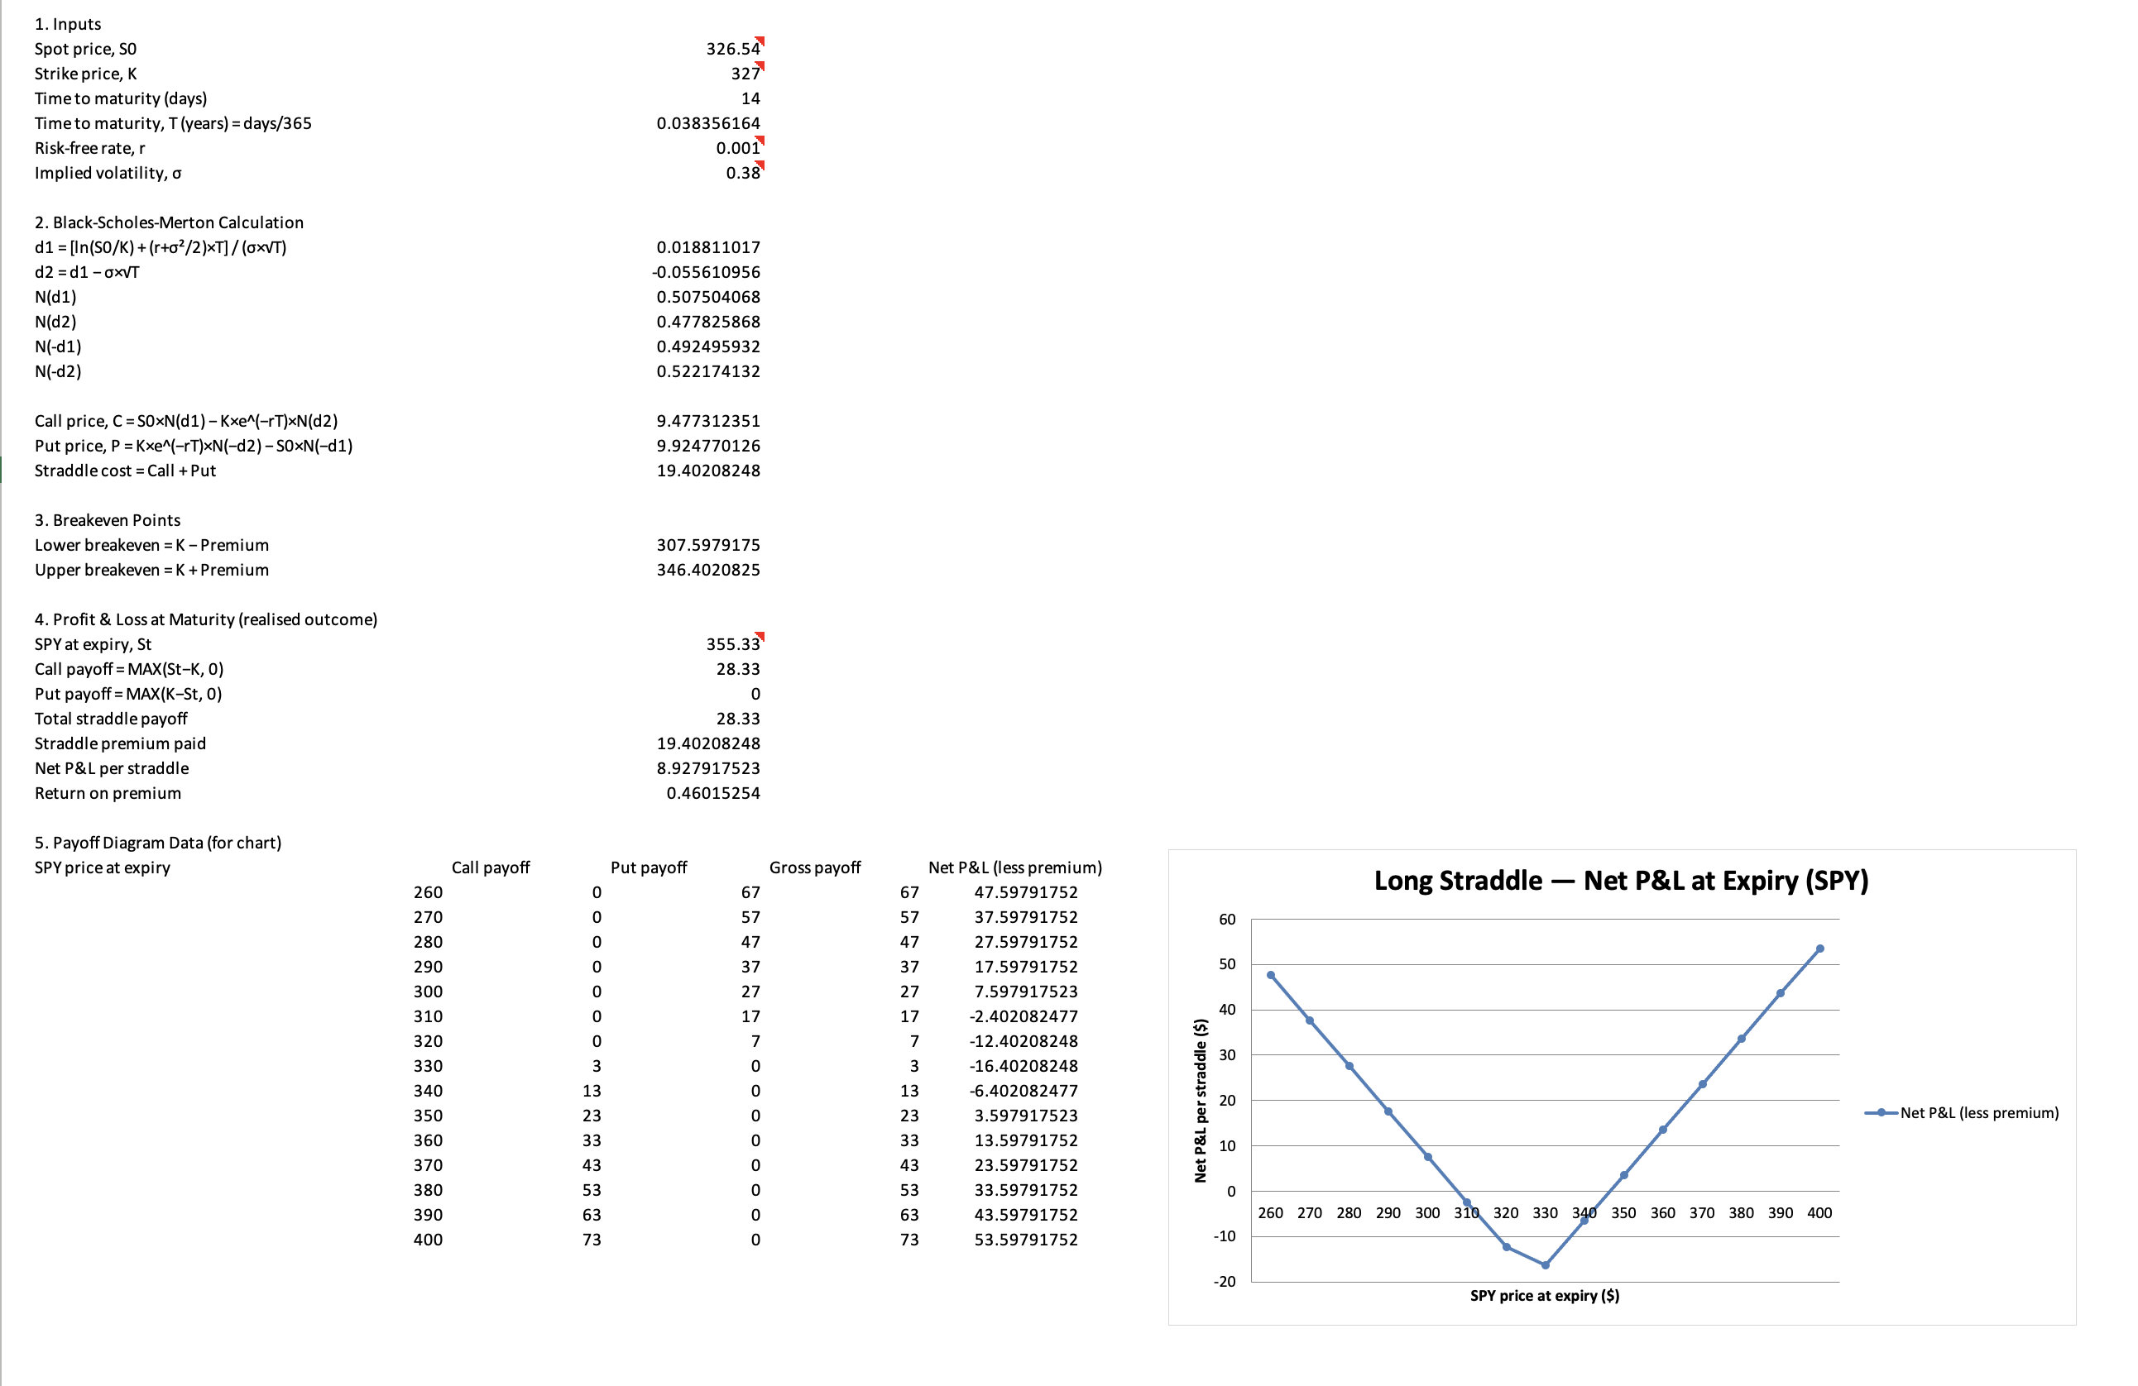
Figure 6: BSM straddle
The selected event is the 2020 U.S. Presidential Election which was conducted on 3 November 2020 between the incumbent President, Donald Trump and his challenger, Joe Biden. The event comprised very large outcome uncertainty into election night: The narrowing of polling in key swing states had meant that the outcome was not known until 7 November, the process of mail-in ballots took too long to confirm the outcome, and markets were genuinely bimodal in the set of policy outcomes of each candidate, including differing corporate tax paths, regulatory posture, and size of fiscal stimulus. This confusion showed in a high CBOE Volatility Index (VIX) before the event, which is also in line with an established history of greater-than-average sector-return dispersion at the time of U.S. presidential elections (Sidhu & Saxena, 2026).
Security Selection
It used the SPDR S&P 500 ETF Trust (SPY), or S&P 500 index ETF as the underlying security. The reason why SPY is considered a single-name stock over a broad market index is that a broad market index isolates idiosyncratic company-specific risks, making it a better vehicle to a pure volatility/event strategy, and the large and liquid options market supporting its market is a reasonable assumption of premium and strike.
Strategy Development
It chosen a long straddle at the same time that a call in the money and a put in the money were applied with the same strike and expiry date. The motivation is that the strategy gains when there is a big price swing in either direction, as is the case with an event with high outcome uncertainty but, truly, two-sided risk (the win of either candidate was possible, and both led to a different, but not necessarily more or less bullish market response) (Choi et al., 2022). Directional approach, like a single call or put, would have involved committing to a certain position in regard to the election results and the way they would affect the market, which an investor in the position prior to the event could hardly do with confidence.
SPY: Hypothetical strategy parameters are: SPY spot price is a representation of the market price of the exchange-traded fund: in this case, that is 326.54 (the closest to the actual value of the day before the election and before it is announced), an at-the-money strike which is: 327 and a two-week maturity (14 days) to cover the time between the election and the announcement of the result, a risk-free rate of 0.10% (near the actual rates in late 2020) and an implied volatility of 38, based on the high levels of the VIX in the run up to the U.S. presidential elections.
Black-Scholes-Merton Pricing
The prices of options were determined by using the BSM formulae:
C = S₀N(d1) − Ke^(−rT)N(d2) P = Ke^(−rT)N(−d2) − S₀N(−d1)
where d1 = [ln(S₀/K) + (r + σ²/2)T] / (σ√T) and d2 = d1 − σ√T.
Payoff Diagram
The maximum payoff of a long straddle, both at expiry, is V(S N) = (S N -K), 0 (K -S N), 0 -premium and results in the typical V-shaped payoff shown below and takes (theoretically) unrestricted losses as the underlying moves further out of the money either way.
Profit and Loss Analysis on Maturity
A sharp rise in S&P 500 (through SPY) was associated with the rapidity of the outcome after the election, along with the optimistic news of the COVID-19 vaccine in mid-November 2020; SPY, which is approximately as two weeks after the position was initiated, closed around $355.33 by mid-November 2020 (Boukai, 2020).
The realised movement of about 8.8% in the underlying within the period of the two weeks was big to shift far beyond the combined breakeven point of the straddle (K ± premium, i.e. around $307.60 and $346.40) earning a net profit amount of 8.93 per straddle, 46.0% of the premium invested. This explains the basic logic behind the plan: since this is not a hedge where a right directional call is needed, it picked up the realised volatility around the election and subsequent vaccine catalyst irrespective of which of the specific events made the market move.

6. Conclusion
This report has illustrated a combined method in setting up investment strategy in both the equity and fixed income and derivatives markets. It was found that intrinsic valuation based on dividends significantly undervalued low-payout, buyback-oriented retailers like Walmart and Costco, and relative valuation provided a more finely tuned perspective on the discounted-but-improving Target, alongside an argument to play a moderate activity, tilted equity strategy. The analysis on fixed income proved that the two duration and convexity are needed and complementary instruments to liability-driven investing: the shorter the duration, the lower the convexity of Bond A and the better tool to suit the given five-year liability was a passive immunisation process over an active duration management. The derivatives analysis demonstrated that the successful hedge of the realised post-election volatility was obtained after entering into a long straddle around the 2020 U.S. election with a priced instrument, the Black-ScholesMerton model, and generating a 46 per cent return on the premium, thereby demonstrating the value of unidirectional strategies involving binary political events. Combined, the report offers a hybrid portfolio; passive, cash-flow-matched fixed income investment to fund liabilities and moderate active equity tilts where the valuation evidence is most robust and supported in all by a sensitivity to the assumptions and limitations of any given valuation and pricing technique applied.
References
Bank, E. C. (2024). Financial Stability Review. Www.ecb.europa.eu. https://www.ecb.europa.eu/press/financial-stability-publications/fsr/html/index.en.html
BIS. (2023). BIS Quarterly Review, September 2023. Www.bis.org. https://www.bis.org/publ/qtrpdf/r_qt2309.htm
Boukai, B. (2020, May 18). How much is your Strangle worth? On the relative value of the $\delta-$Symmetric Strangle under the Black-Scholes model. ArXiv.org. https://doi.org/10.48550/arXiv.2003.03876
Chen, J. M. (2021). The Capital Asset Pricing Model. Encyclopedia, 1(3), 915–933. mdpi. https://doi.org/10.3390/encyclopedia1030070
Chen, P., & Deng, L. (2023). Does venture capital Quan Zi affect stock mispricing: Evidence from Chinese listed companies. PLOS ONE, 18(4). https://doi.org/10.1371/journal.pone.0281255
Choi, J., Kwak, M., Tee, C. W., & Wang, Y. (2022). A Black–Scholes user’s guide to the Bachelier model. Journal of Futures Markets, 42(5), 959–980. https://doi.org/10.1002/fut.22315
Gálvez, J. (2023). MEASURING THE EQUITY RISK PREMIUM WITH DIVIDEND DISCOUNT MODELS 2022. https://www.bde.es/f/webbde/SES/Secciones/Publicaciones/PublicacionesSeriadas/DocumentosOcasionales/22/Files/do2207e.pdf
Gankhuu, B. (2022). Parameter Estimation Methods of Required Rate of Return on Stock. ArXiv:2206.09657 [Q-Fin]. https://arxiv.org/abs/2206.09657
Gruszka, J., & Szwabiński, J. (2023). Portfolio Optimisation via the Heston Model Calibrated to Real Asset Data. ArXiv.org. https://arxiv.org/abs/2302.01816
IMF. (2023, October). Global Financial Stability Report, October 2023: Financial and Climate Policies for a High-Interest-Rate Era. IMF. https://www.imf.org/en/Publications/GFSR/Issues/2023/10/10/global-financial-stability-report-october-2023
Li, W., Zhang Jing-qi, & Chen, L. (2022). Cash dividends, return on equity and earnings persistence. Ekonomska Istrazivanja-Economic Research, 36(1), 2298–2319. https://doi.org/10.1080/1331677x.2022.2097106
Li, Y., & Wang, C. (2023). Valuation Duration of the Stock Market. ArXiv.org. https://arxiv.org/abs/2310.07110
Maharani, A., & I Made Narsa. (2023). Six-factor plus intellectual capital in the capital asset pricing model and excess stock return: Empirical evidence in emerging stock markets. Cogent Economics & Finance, 11(2). https://doi.org/10.1080/23322039.2023.2252652
OECD. (2024). Finance and investment. OECD. https://www.oecd.org/en/topics/finance-and-investment.html
Sidhu, K. S., & Saxena, P. (2026). Beyond Black-Scholes: A Computational Framework for Option Pricing Using Heston, GARCH, and Jump Diffusion Models. ArXiv.org. https://arxiv.org/abs/2604.06068
Șimandan, R., Leuștean, B., & Dobrescu, R. M. (2022). An Uphill Battle: Financial Education in Romania in the Midst of Societal Transformation. Journal of Risk and Financial Management, 15(11), 494. https://doi.org/10.3390/jrfm15110494
Wolf, S. E., Hastings, W. J., Ye, Q., Etzel, L., Apsley, A. T., Chiaro, C., Heim, C. C., Heller, T., Noll, J. G., Schreier, H. M. C., Shenk, C. E., & Shalev, I. (2024). Cross-tissue comparison of telomere length and quality metrics of DNA among individuals aged 8 to 70 years. PLOS ONE, 19(2), e0290918. https://doi.org/10.1371/journal.pone.0290918
Yahoo Finance. (2024). Target Corporation (TGT) Stock Price, News, Quote & History - Yahoo Finance. Finance.yahoo.com. https://finance.yahoo.com/quote/TGT/
Yahoo Finance. (2025). Walmart Inc. (WMT) Stock Price, Quote, History & News - Yahoo Finance. @YahooFinance. https://finance.yahoo.com/quote/WMT/
Yahoo Finance. (2026). Costco Wholesale Corporation (COST) Stock Price, News, Quote & History - Yahoo Finance. Finance.yahoo.com. https://finance.yahoo.com/quote/COST/
Yang, R., & Shi, B. (2023). Sector Rotation by Factor Model and Fundamental Analysis. ArXiv.org. https://arxiv.org/abs/2401.00001

